

**CSE 1005: SOFTWARE ENGEERING**

**EMPLOYEE PAYROLL SYSTEM (EPS)**

**TEAM GUIDE**

**DR. HUSSAIN SYED**

**TEAM MEMBERS**

**1.20BCE7105 – S.SAI SREEKAR**

**2.20BCE7425 – S.SAI CHARAN**

**3.20BCE7280 – Y.V.N ASHISH**

1. **Introduction:**

* 1. **Purpose:**

This document is intended to outline the characteristics of EPS so that it can be used as a reference for developers and a software validation document for potential clients.

Payroll software integrates with other core business systems to ensure that employees receive accurate,on-time compensation in appropriate manner. Employees can typically access the softwre to edit their personal information, payment prefernces, and other details.

* 1. **Intended Audience :**

**Stakeholders –** Payroll manager, HR system managers, central Finance officers, payroll vender system.

**Users –** Employees, Staff, Workers

* 1. **Intended Use :**

This Payroll system is very better for the employees to keep monitoring of their salary with holding taxes, attendance and other deductions . It should be east for the stakeholders to verify the employees worked hours and their leaves based on that they provide salaries. By this major problems and money issues will be reduced.

* 1. **Scope:** 
     + - 1. The system deals with the financial aspects of employee’s salary, deductions,allownces,netpay.
         2. The user can view the account of each and every empliyee’s and update their payments.
         3. Each and every detail about employee’s payment is displayed which includes: Name with deduction, overtime, bonus and net pay.
         4. This system makes easier to the user for managing payroll system as it is not time-consuming
         5. This project is not difficult to operate and understood by the users.

* 1. **Definitions and Acronyms:**

**EPS –** employee payroll system (For employees details to monitoring )

**SRS -** Software Requirement Specification

**Stakeholder -** The person who will participate in system

**Ex**. Admin, developers, target audience, funders, web clients.

* 1. **References:**

User Interface Style Guides, Contracts, Standards, System requirements Specifications, and we contact with our college and other organization employees for needs.

* 1. **Overview:**

“Employee Payroll Management System” is designed to make the existing manual system automatic with the help of computerised equipment and full-edged computer software, fulfilling their requirements, so that their valuable data and information can be stored for a longer period with easy access and manipulation of the same. The required software is easily available and easy to work with. This web application can maintain and view computerised records without getting redundant entries. The project describes how to manage user data for good performance and provide better services for the client

1. **Overall Description:**

The proposed project “Employee Database and Payroll Management System” has been developed to overcome the problems faced in the practicing of manual system. This software is built to eliminate and in some cases reduce the hardships faced by the existing system. Moreover this system is designed for particular need of the company to carry out its operations in a smooth and effective manner. This web application is reduced as much as possible to avoid errors while entering data. It also provides error message while entering invalid data. It is user-friendly as no formal knowledge is required to use the system. Human resource challenges are faced by every organization which has to be overcome by the organization. Every organization has different employee and payroll management needs. Therefore I have design exclusive Employee and payroll Management System that are adapted to the organization’s Managerial Requirements.

* 1. **Purpose**:

The purpose of this document is to describe the functionality and specifications of the design of a web application for Managing Employees and their payroll. The expected audiences of this document are the developers and the admin of the web application. Now with the help of this system the admin has the information on his finger tips and can easily prepare a good record based on their requirements. Finally, we can say that this system will not only automate the process but save the valuable time of the manager or the admin, which can be well utilized buy his institute. This will be an additional advantage and management of power based on their free time from his normal duty.

* 1. **Advantages :**

It is cost effective as the user control the web application himself and does not go for professional service.

It saves time as it speeds up every aspect of the employee database management and payroll process with a range of automated features. • It is secure as the employee database and the payroll process is managed by the admin in house rather than sending private information to a third party.

Validating procedures and checks restrict user from making mistakes.

The software is easy to use and is user friendly so no expertise is required.

The calculations are automated so no chance of error.

* 1. **Disadvantages :**

* + - * + It requires an internet connection.
        + It requires large database.

* 1. **User Needs**:

User should be familiar terms like

Login

Employee List

Attendance List

Payroll List

Allowance List

Department List

Position List

Users

* 1. **Principle Actors**:

The two Principal Actors are Client (User) and Administrator

(StakeHolder).

* 1. **General Constraints**:

An internet connection is required for EPS.

1. **System Features and Requirements:**

* 1. **Functional Requirements:**

This section gives a high-level summary of the system's requirements. The system will be able to implement a variety of functional modules, including:

* + 1. **Description:**

The key consideration involved in functional requirements are the needs that the end user expresses as essential features that the software should provide.

* + 1. **Login**:

The user logs in to the online application using a valid employee email-id and password that has been successfully validated by selecting that your status by selecting either employee or admin.

* + 1. **Attendance List**:

Every employee after login to the web application need to take the attendance by clicking the “Add attendance” list.

By clicking the add attendance list a pop up will come in that you can fill the details with your name, time in and time out, and date. So, that the employee gets their attendance. This module displayed for both employees and admins. Mandatory for all members.

* + 1. **Employee List**:

Every employee details will be there with their respective department, position, employee name and their id’s.

The users can view the payroll details with their allowance and deduction.

The admins can view and edit/add the allowances and deductions based on their position and performance. These list of each employee created by the admin used to calculate the payroll list for each employee.

* + 1. **Payroll List :**

The payroll list is generated by the list created in the employee list with their salary, allowance and deduction and attendance based on the details the payroll list calculated, after calculating a view button displayed by clicking that the employees can view their salary list then can print their list by clicking the print.

The admins will get a view edit and trash button in the edit button used to change the calculated from date and to date and trash button used to remove the payroll list. By pressing the view button the admin can view the re calculate button where any changes happen those can recalculate the payroll list based on their changes.

* + 1. **Allowance List:**

The users can see the allowances like salary, bonus, loans etc… where the employee get benefits by adding the allowance to the employee list so that the employees get their payroll to the employee by the admin. But the users can display only the list created by the admins.

* + 1. **Department List :**

The list contains the depatments which are present in the company in different sectors. Those departments are maintain and edited by the admin by checking the availability of the ppositons in the company. But the users can only see the department list created by the admins.

* + 1. **Position List :**

The list contains the positions in the department. Each department contains positions which are created by the admins and maintain the list by the admin and put their positon details and give their postion details. The users can see only their postions names and the details of their position.

* + 1. **Users :**

The users can access by the admin only. The access which makes the add users by their first name last name and middle name and we need to give the user name and password based on the login creditionals with constraints and need to mention the admin or staff so that the creditonals get updated to the database and so that they can also access the app from that time.

* 1. **Non-functional Requirements**:

In the insurance to the internet, the following Non-Functional Requirements will be present:

* + - 1. Secure access to a customer's personal information.
      2. Availability 24 hours a day, 7 days a week.
      3. Improved component design to improve peak performance.
      4. For future expansion, a flexible service-based architecture will be particularly desired.
      5. System properties and limitations are defined by

## Non-Functional Requirements : **Security, Reliability,**

**Maintainability, Portability, Extensibility, Reusability,**

**Compatibility, and Resource Utilization** are some of the additional non-functional requirements.

**3.3 Performance Requirements**:

Since any number of employees can use the system at any time, it is necessary to maintain an acceptable performance at the maximum number of users for a single time. Also, connections to the servers will be dependent on the user's qualities, such as his work and the servers will be available 24 hours a day, seven days a week.

**3.4 Technical Issues**:

The client-server architecture will be used in this system. It will necessitate the use of an internet server that can execute PHP applications. The system should support popular browsers such as Internet Explorer, Mozilla Firefox, Chrome, and others.

**3.5 System Features**:

1. Generating and Managing Invoices in a matter of few seconds.
2. Maintain all the products with their shorthand notation.
3. Provides summary reports to owners monthly or weekly & yearly.
4. Provides a convenient solution to the billing pattern.
5. Make an easy to use environment for owners and customers.
6. Secured User Authentication and Validation.
7. User Giveaway generator.

Languages: HTML, PHP, JavaScript

RDBMS: Online MySQL Web Server: WAMP server **Hardware used:**

Processor: Intel core i5

RAM: 8GB

UML DIAGRAMS

USECASE:

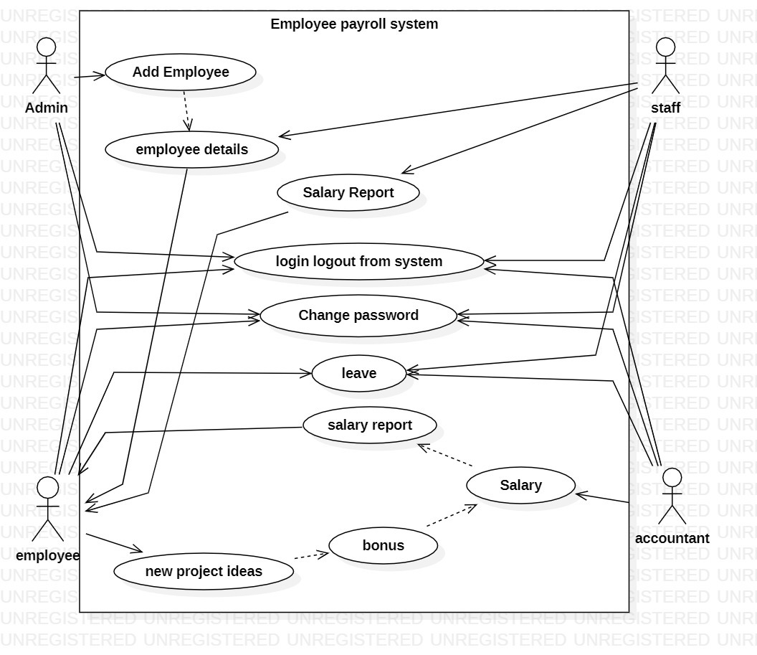

CLASS DIAGRAM:

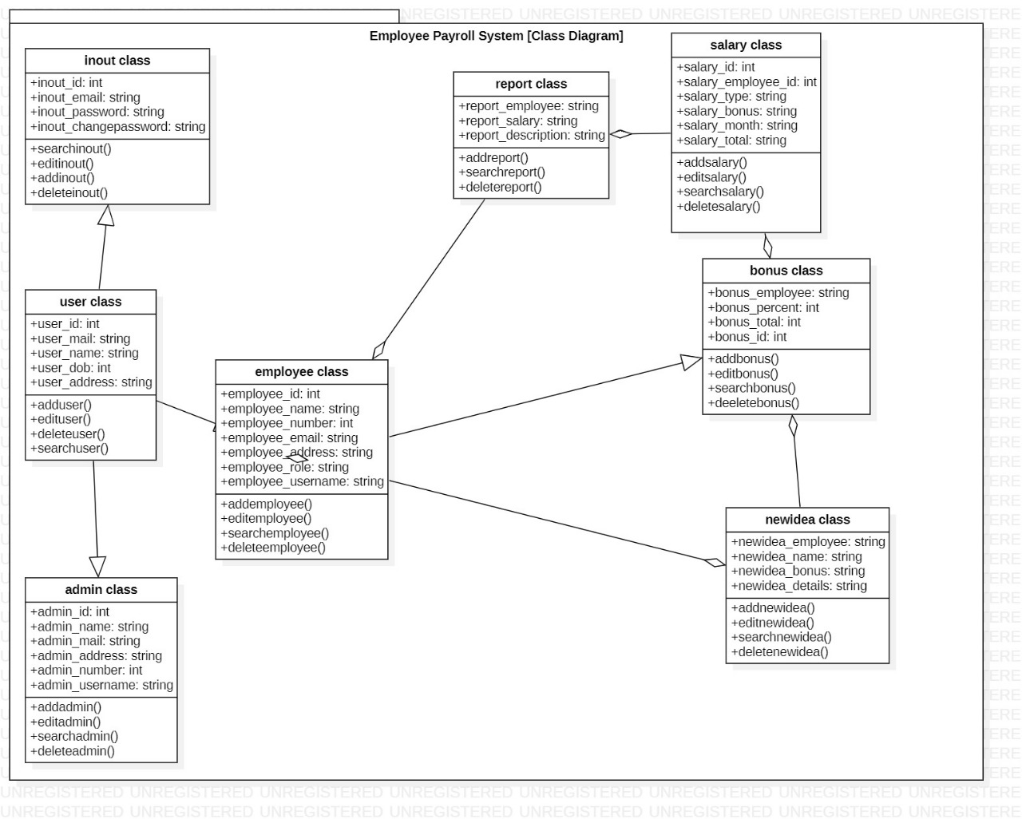

SEQUENCE DIAGRAM :

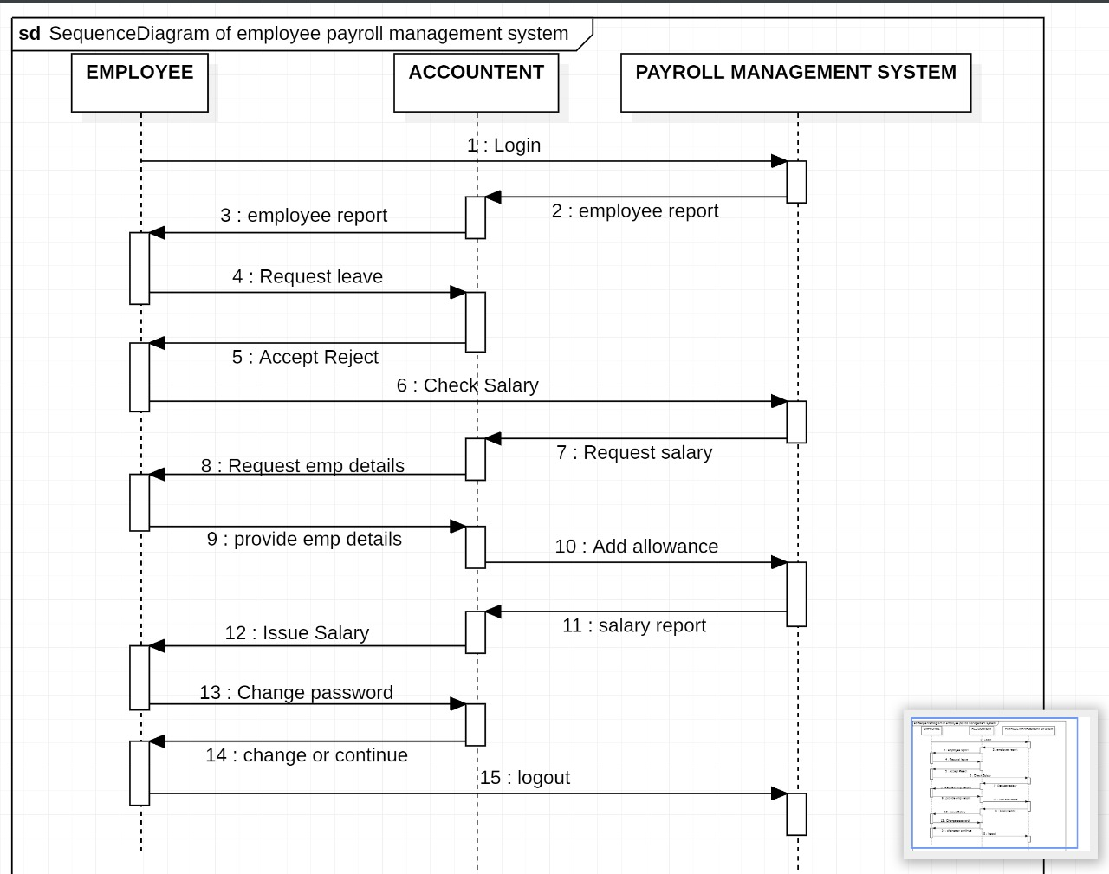

ACTIVITY DIAGRAM:  
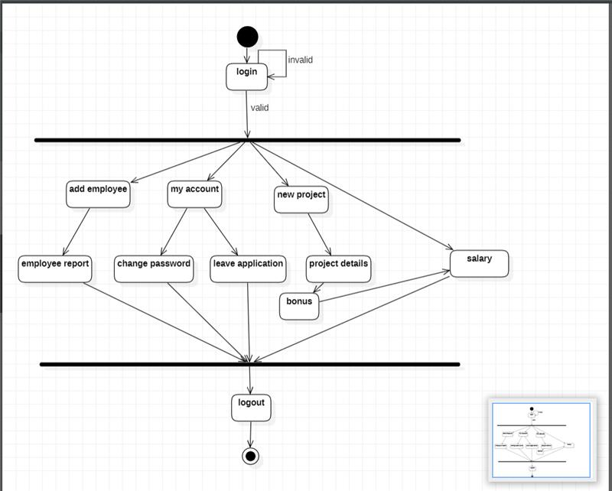

COMPONENT DIAGRAM:

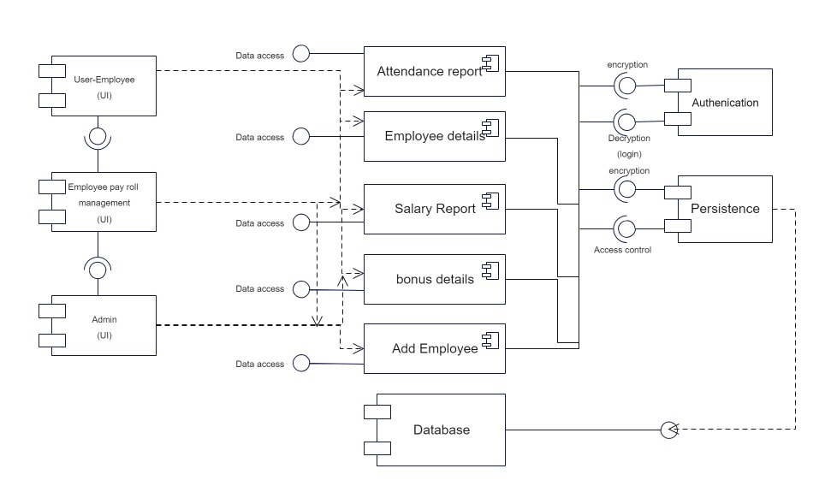

PROTOTYPE:

Users login page :

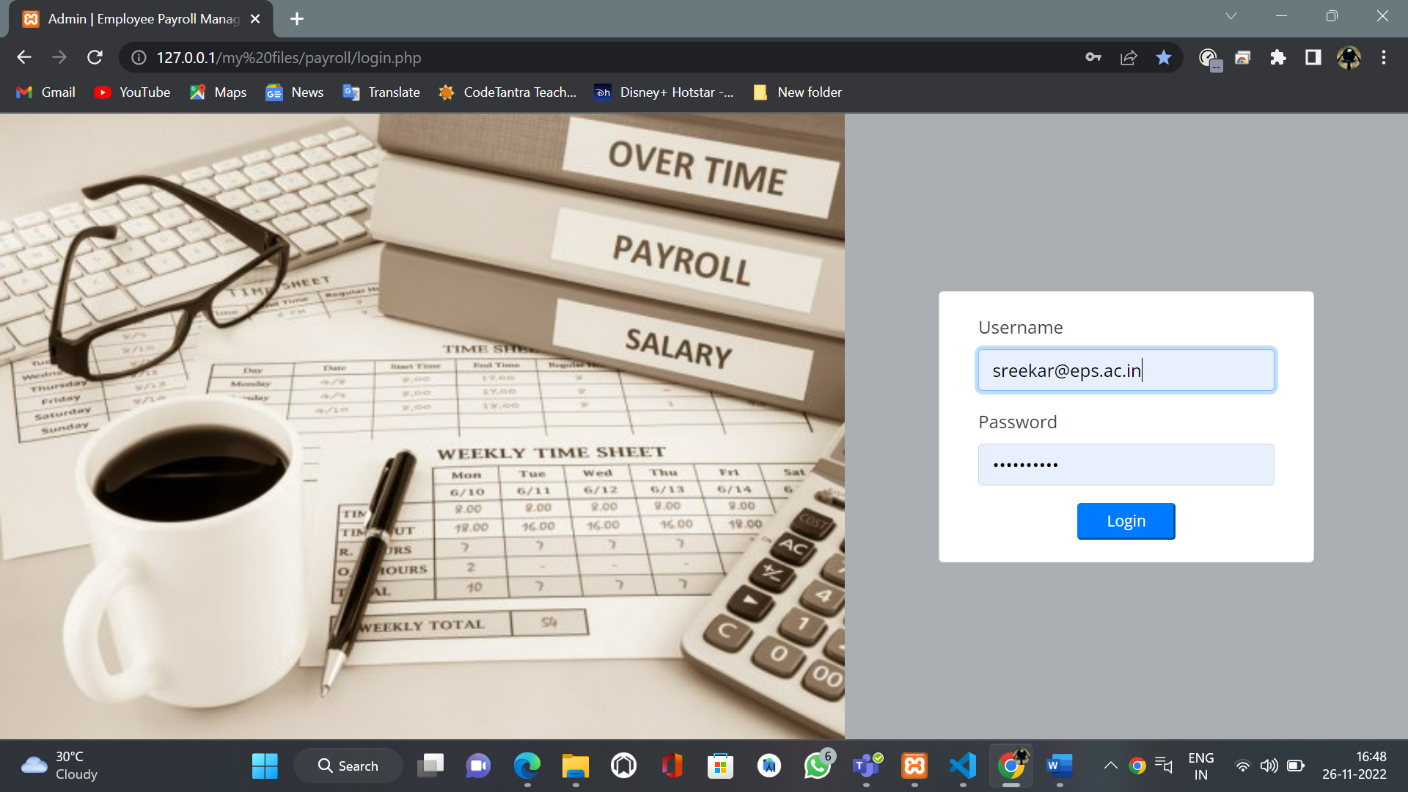

Normal Users inteface Page:

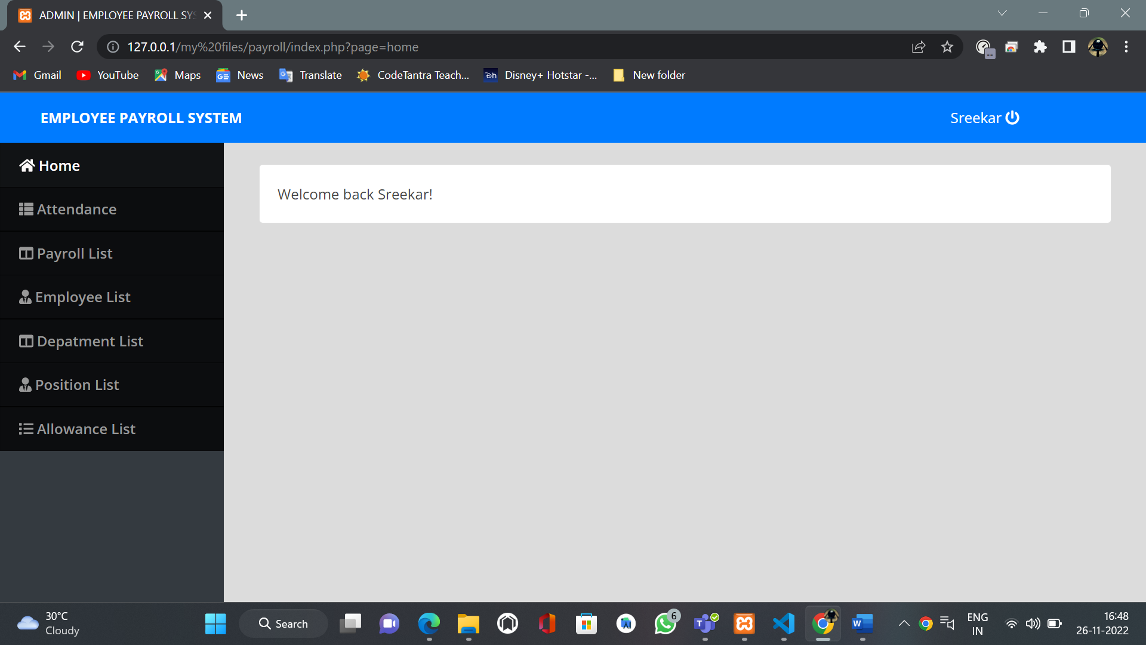

Users attendance Page:

Here, the attendance of every employee will display

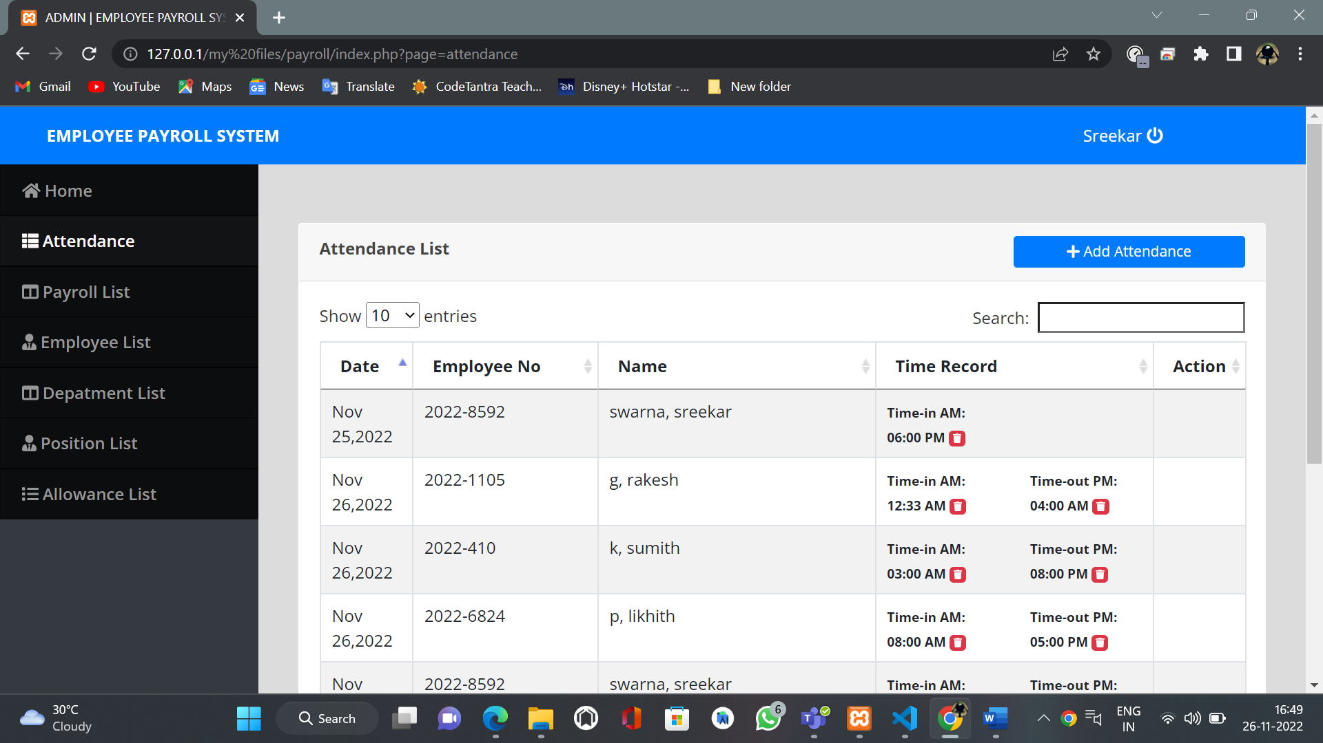

Add attendance list

Here, the employee can add their daily attendance based on their time in and out.

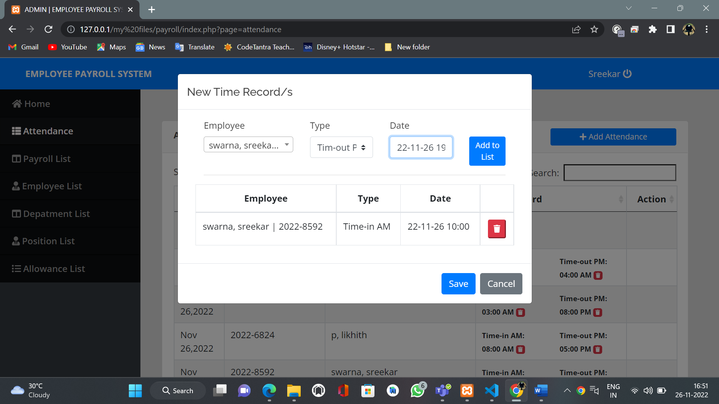

Users Payroll list:

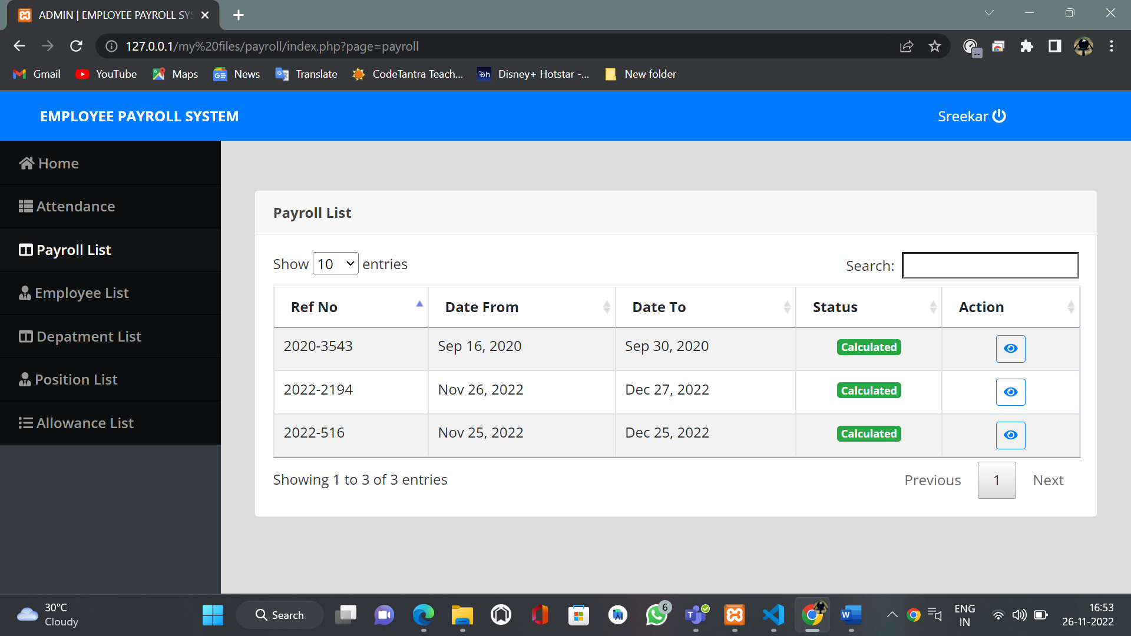

User employee list:

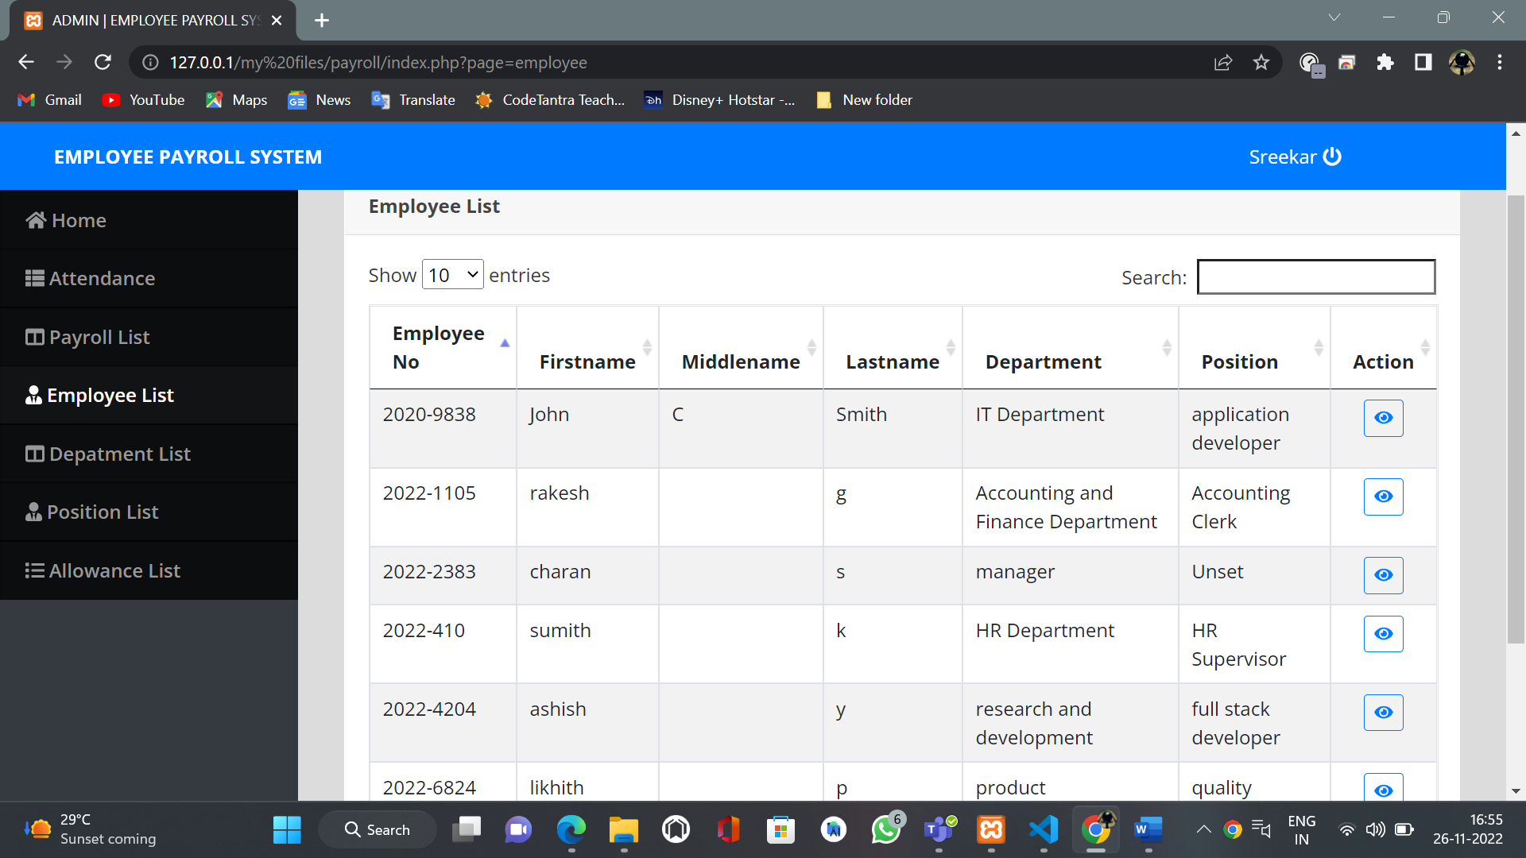

Users department list:

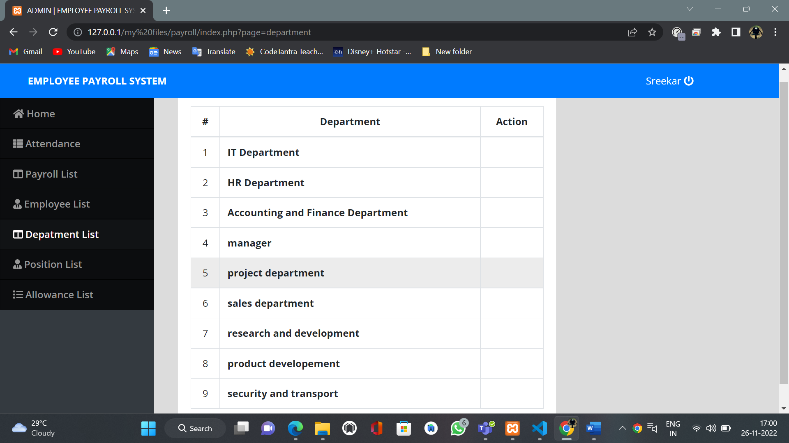

Users position list:

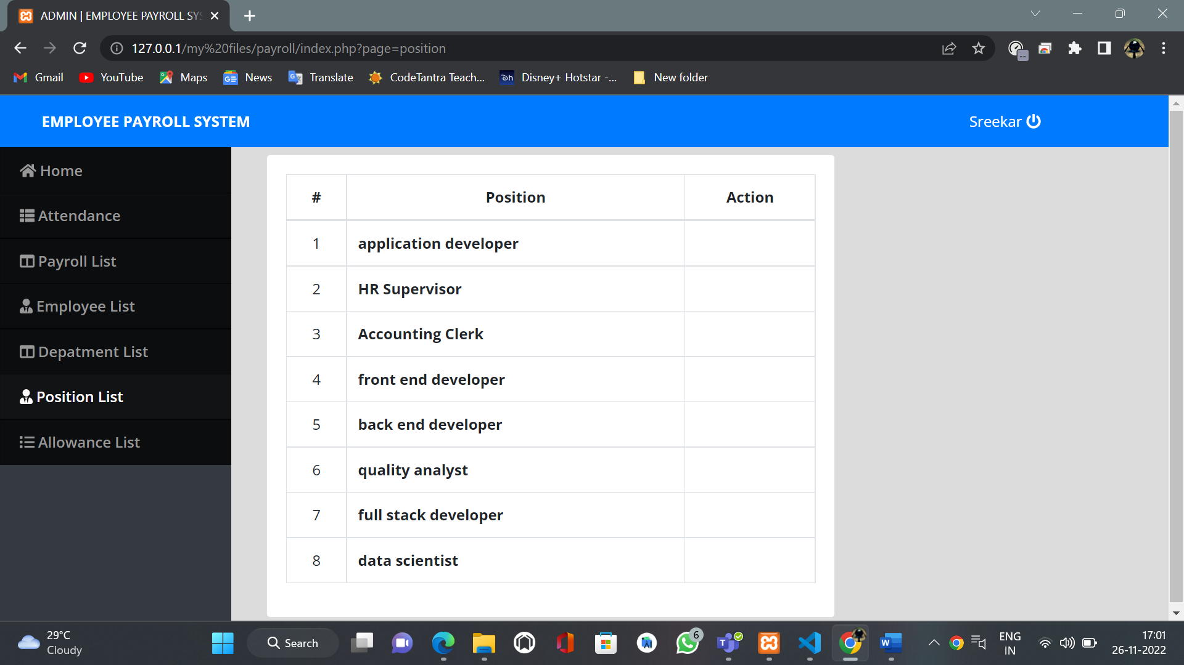

Users allowance list:  
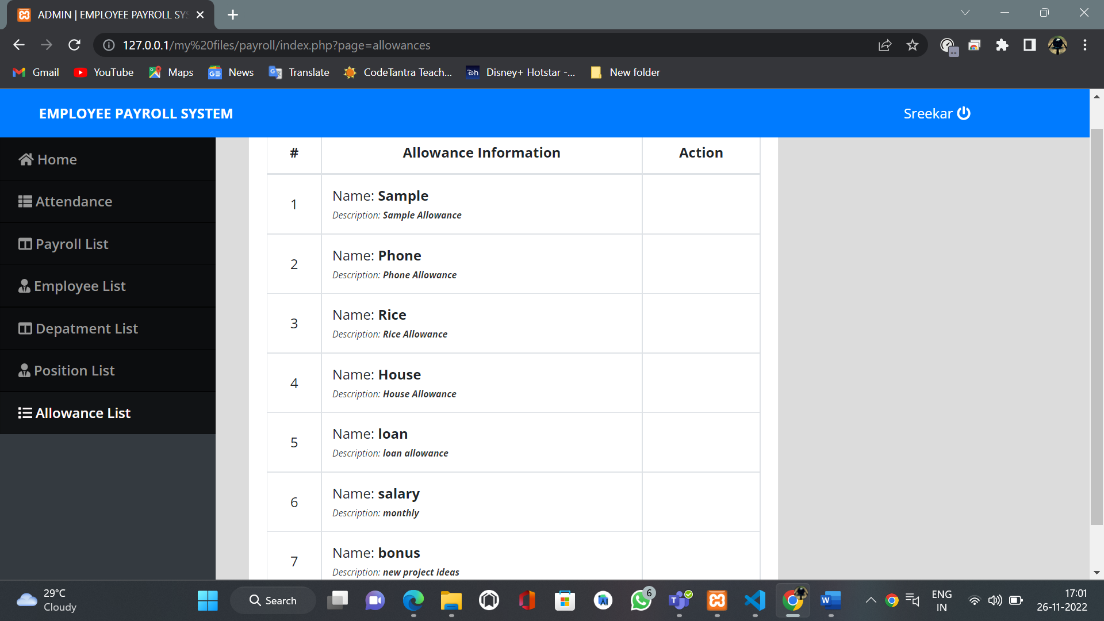

Admin Login page:

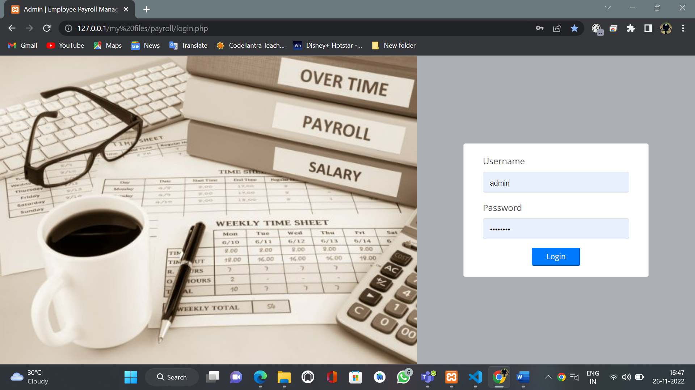

Admin login page:

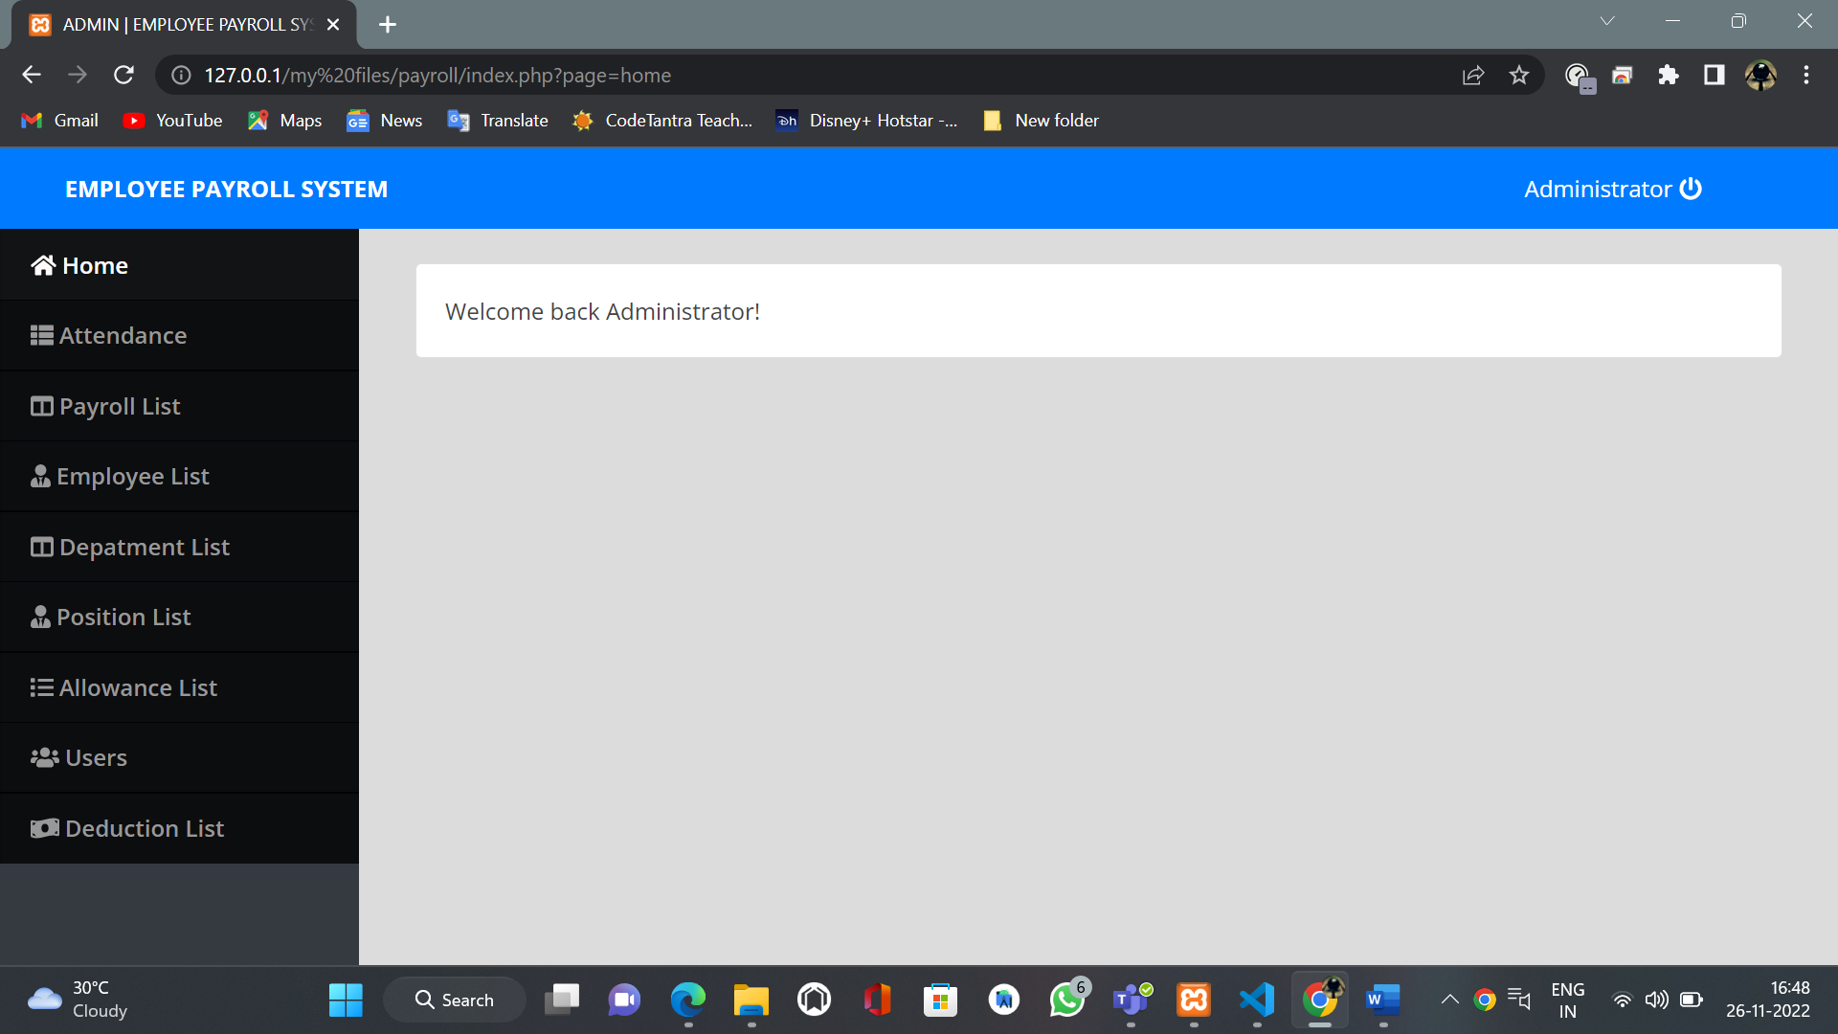

Admin’s attendance list view:  
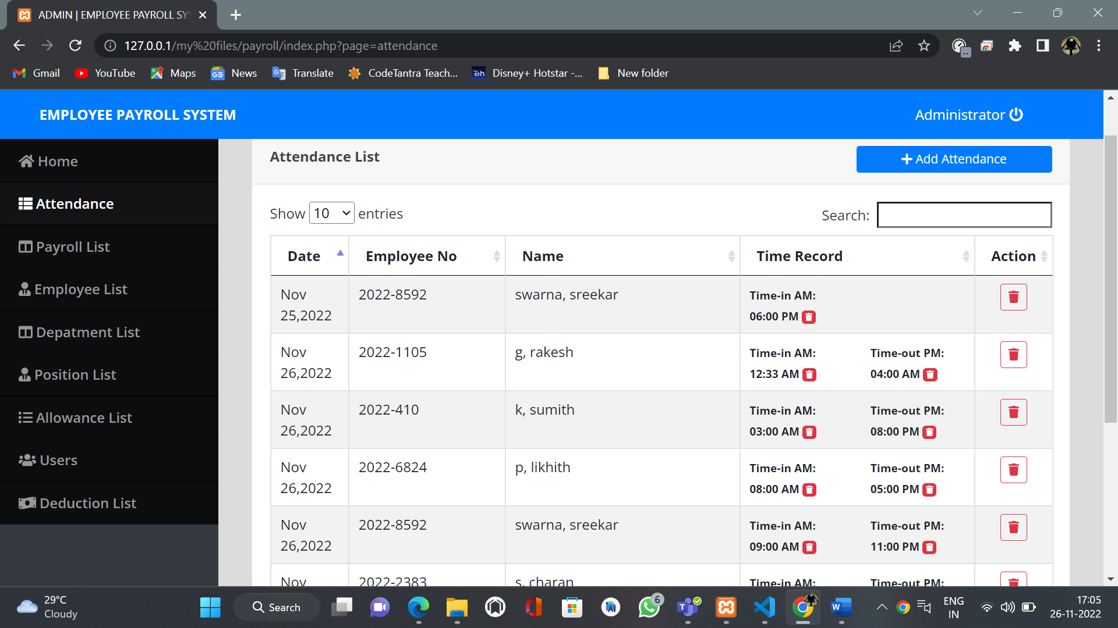

Admins payroll list:

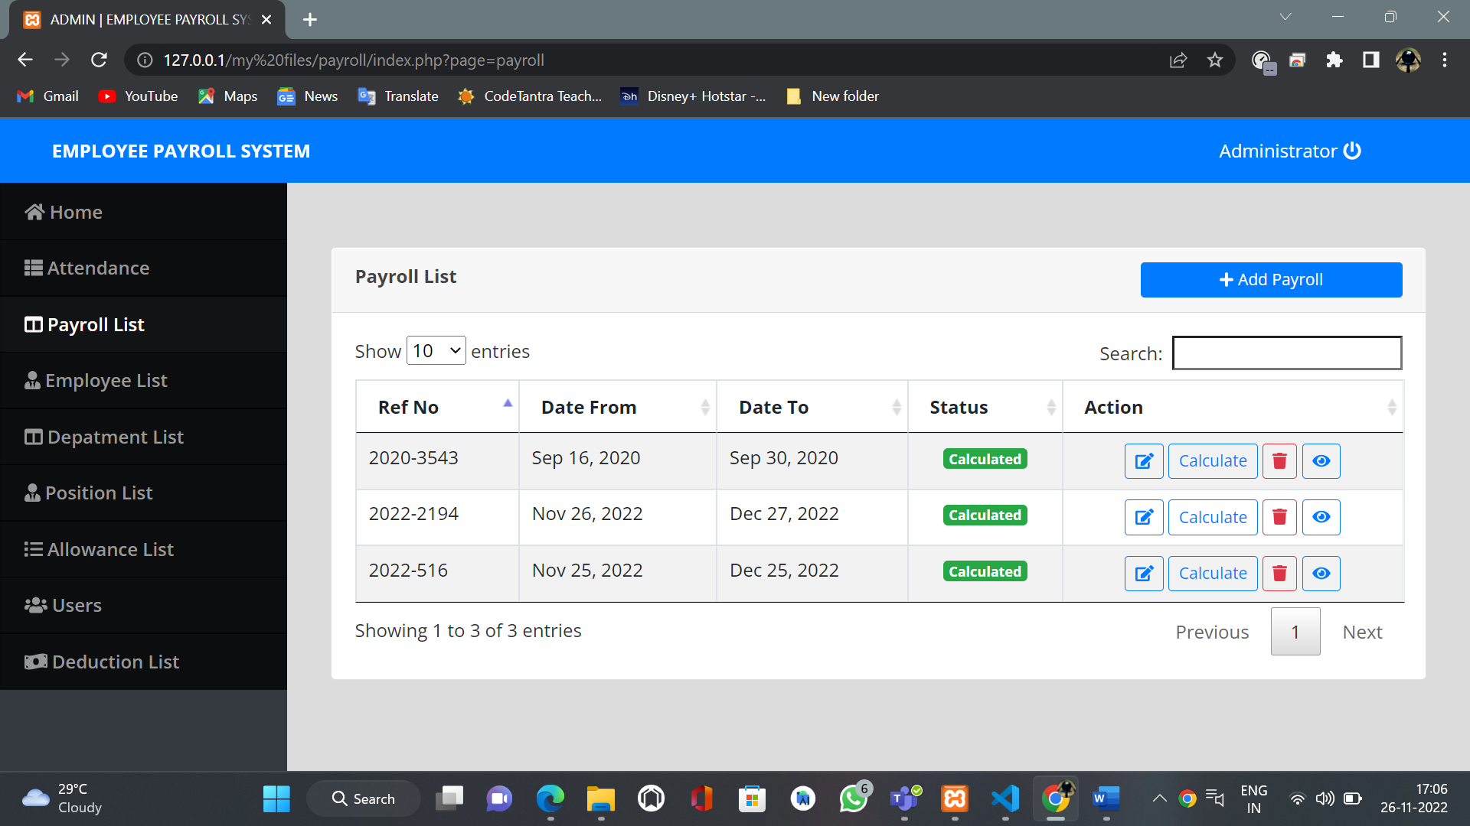

New payroll list:

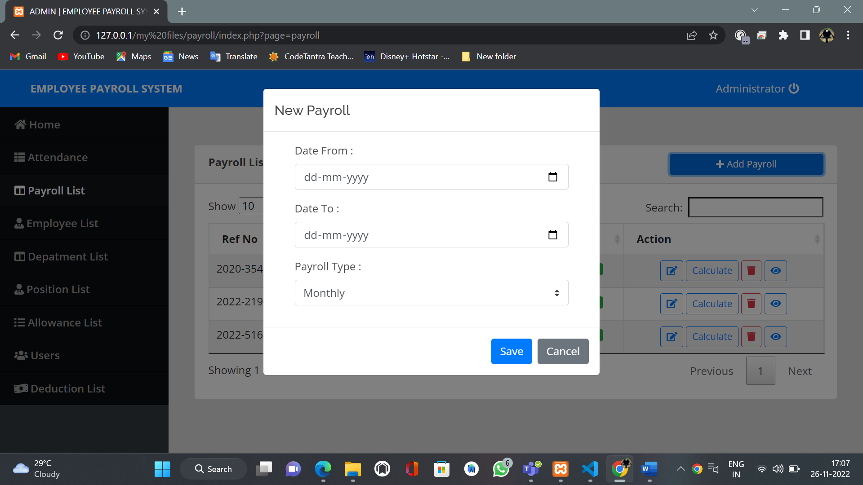

Admins employee list:

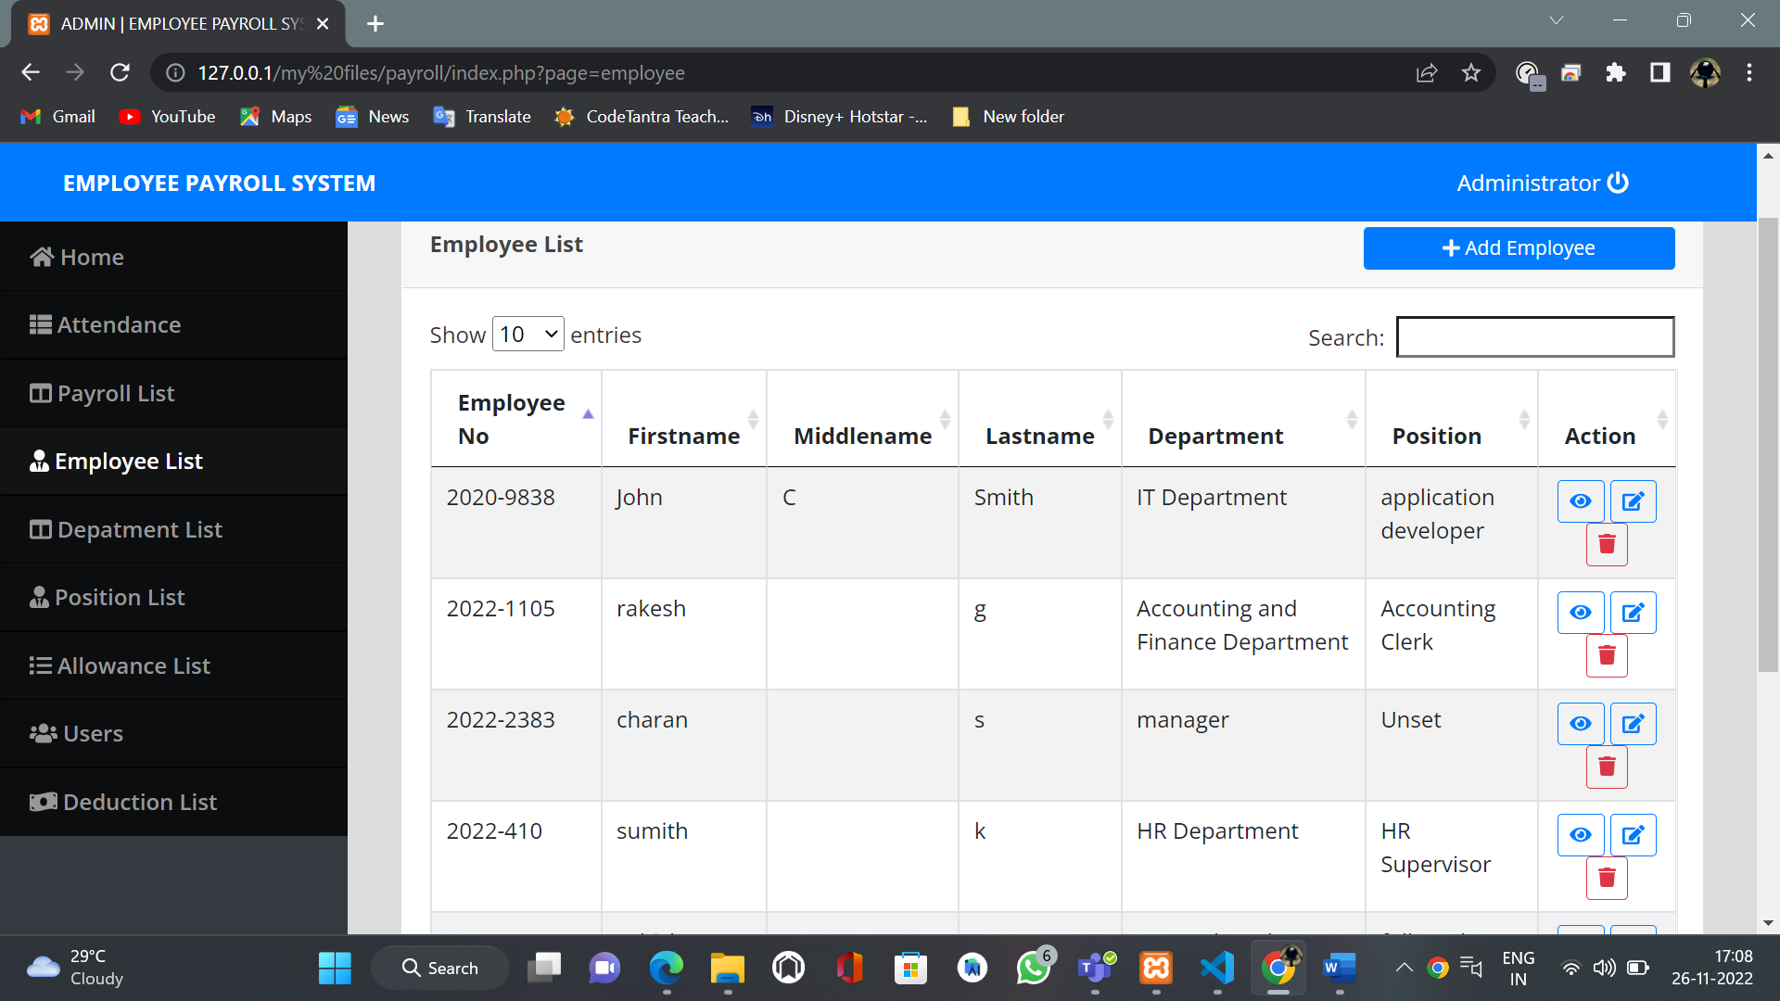

New employee list:  
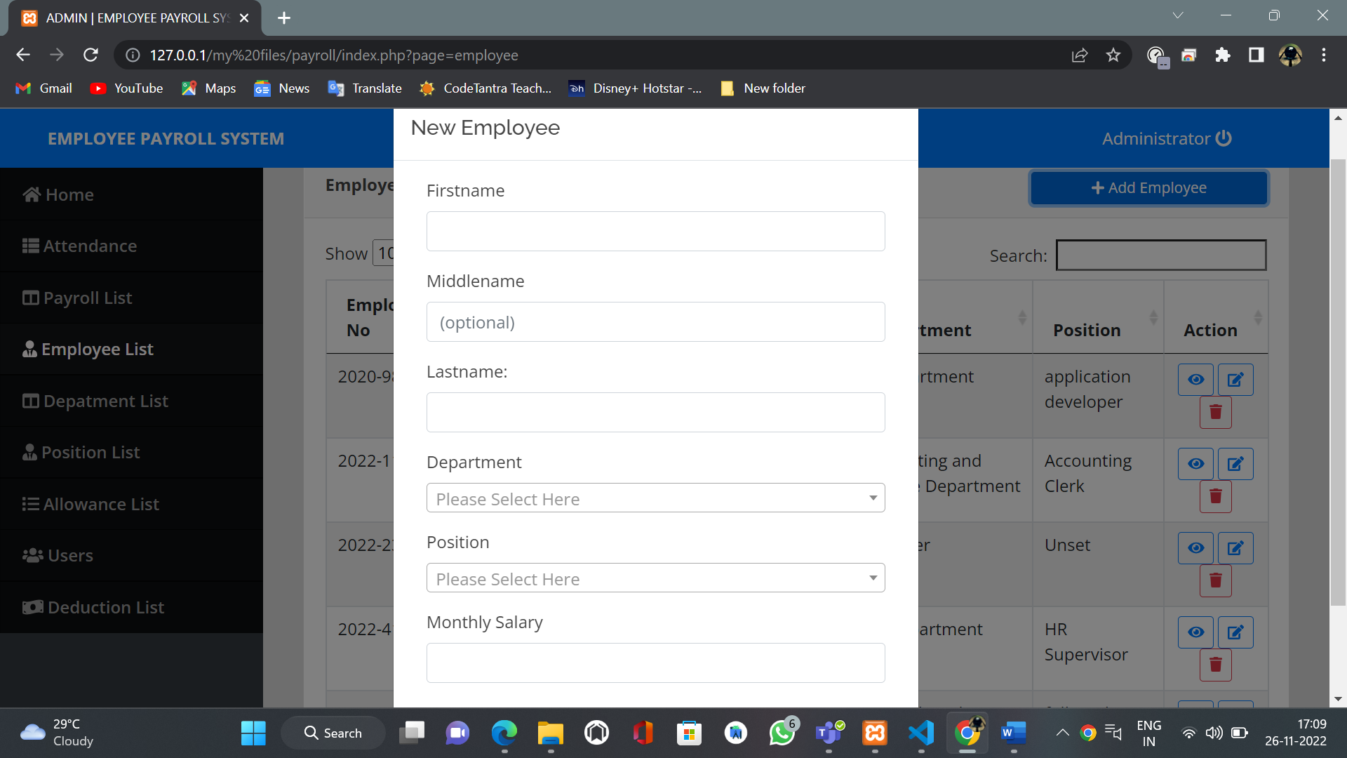

Employees allowance and deduction list:

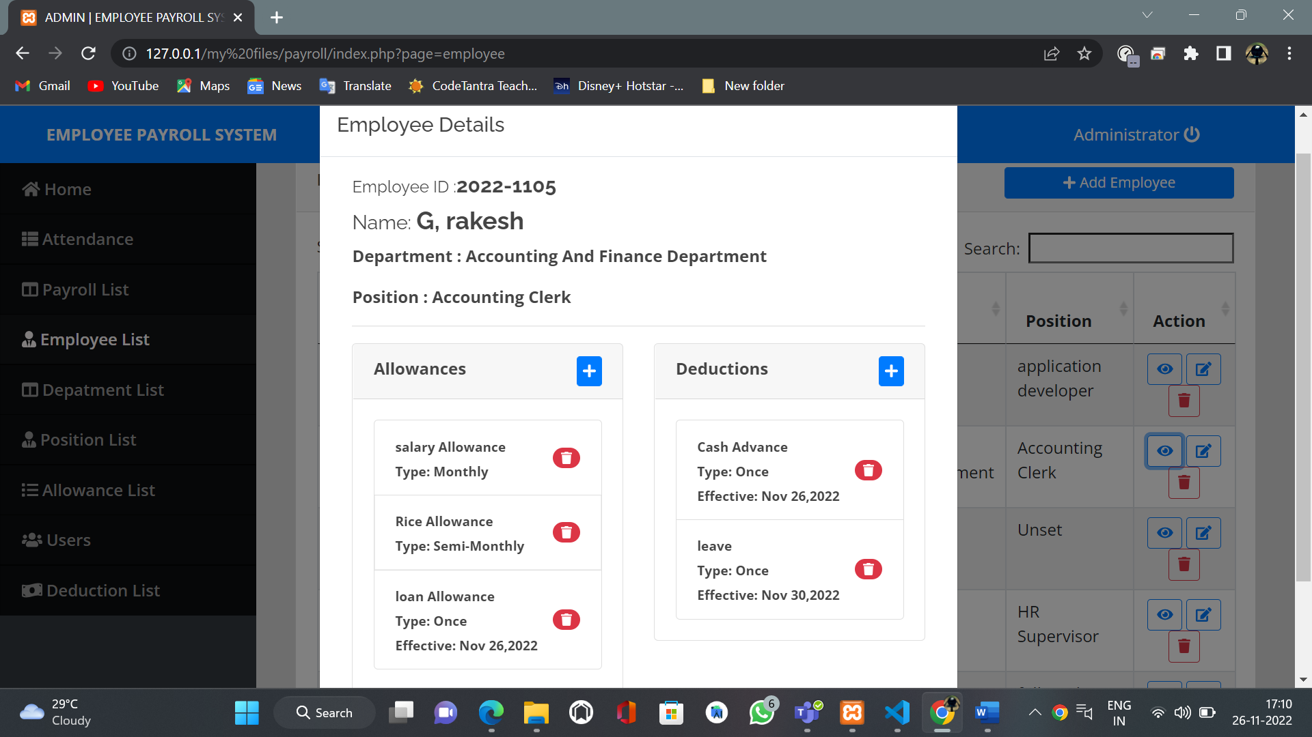

Admins Department list:  
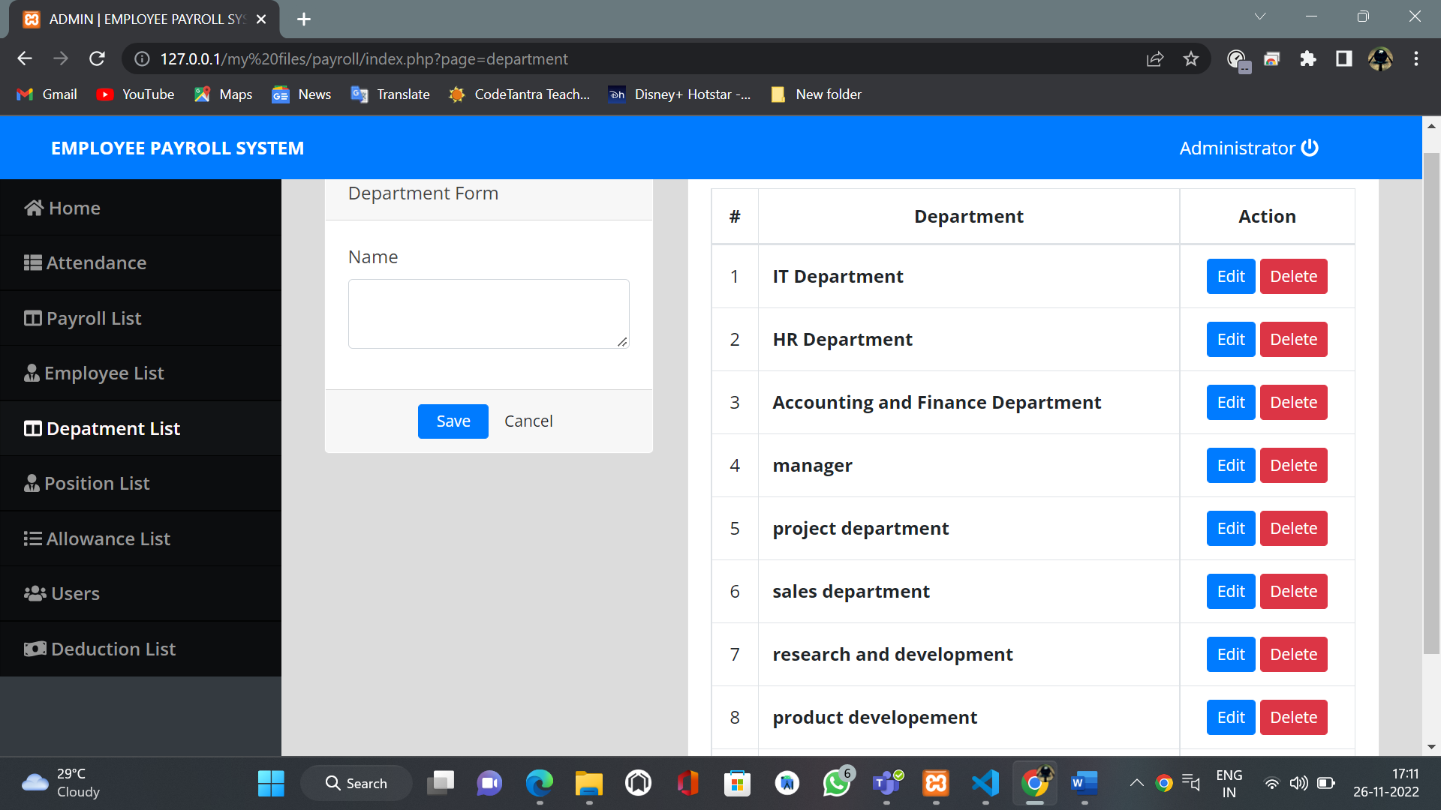

Admins position list:

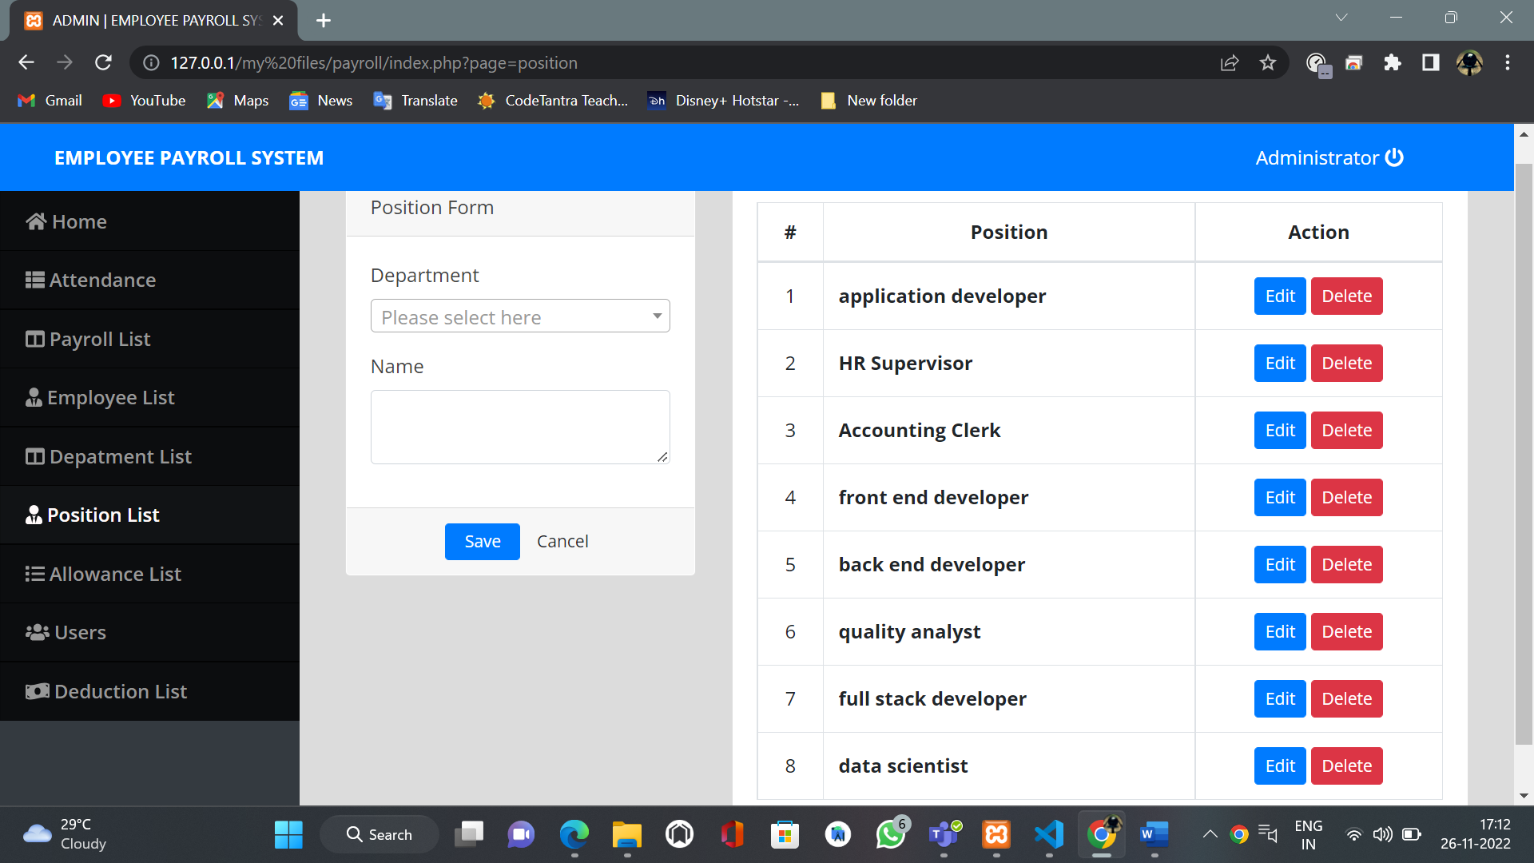

Admins allowance lilst:

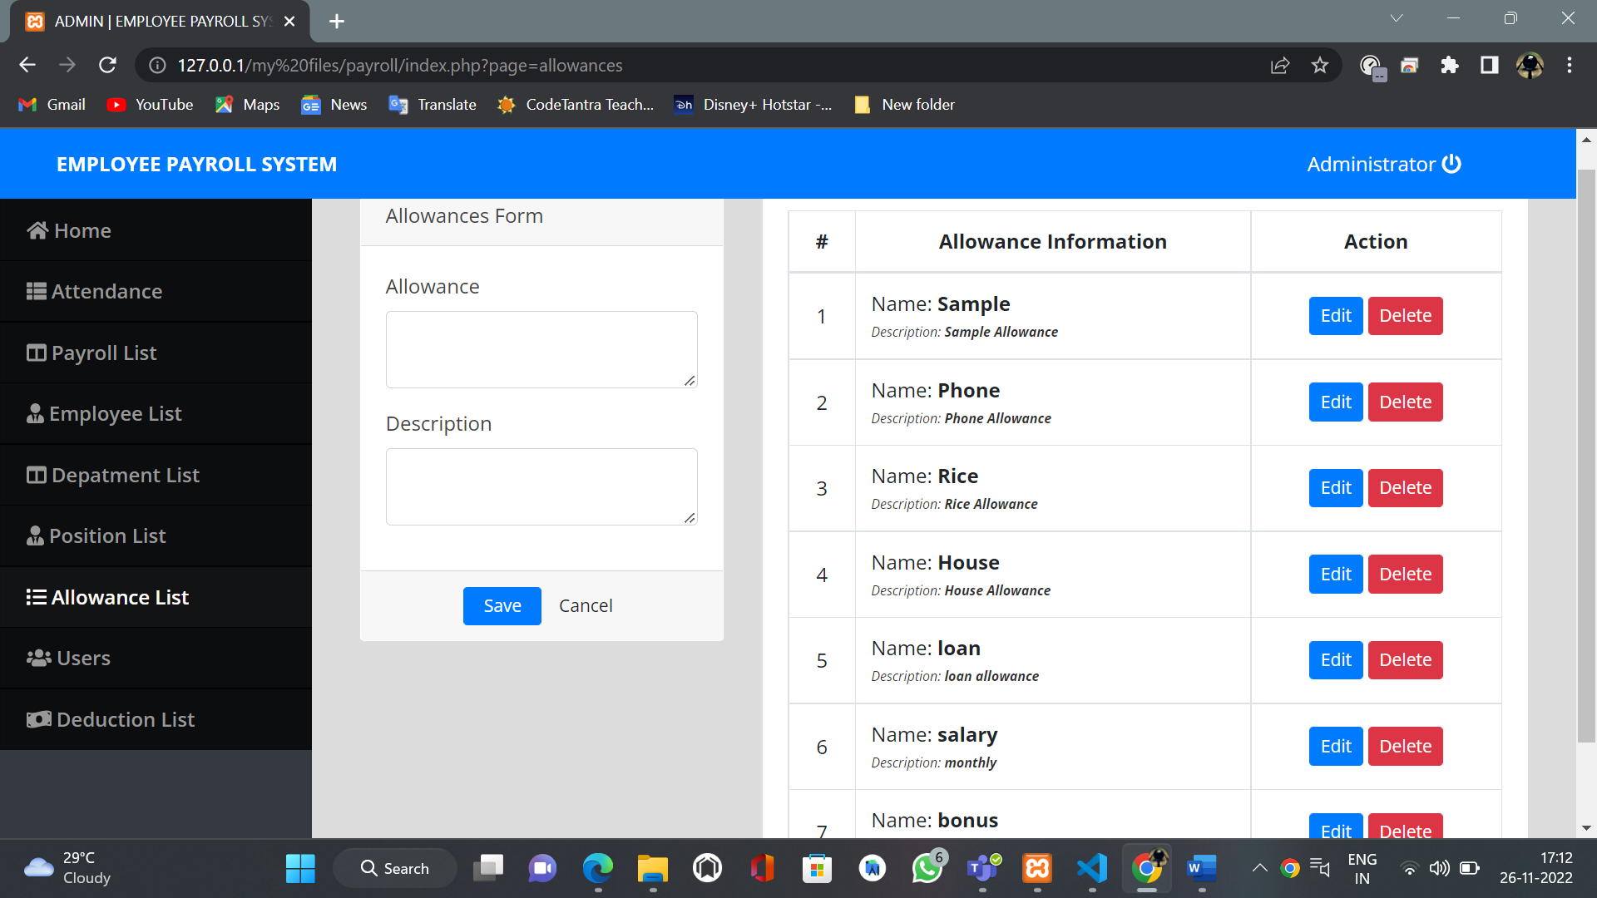

Admins deduction list:  
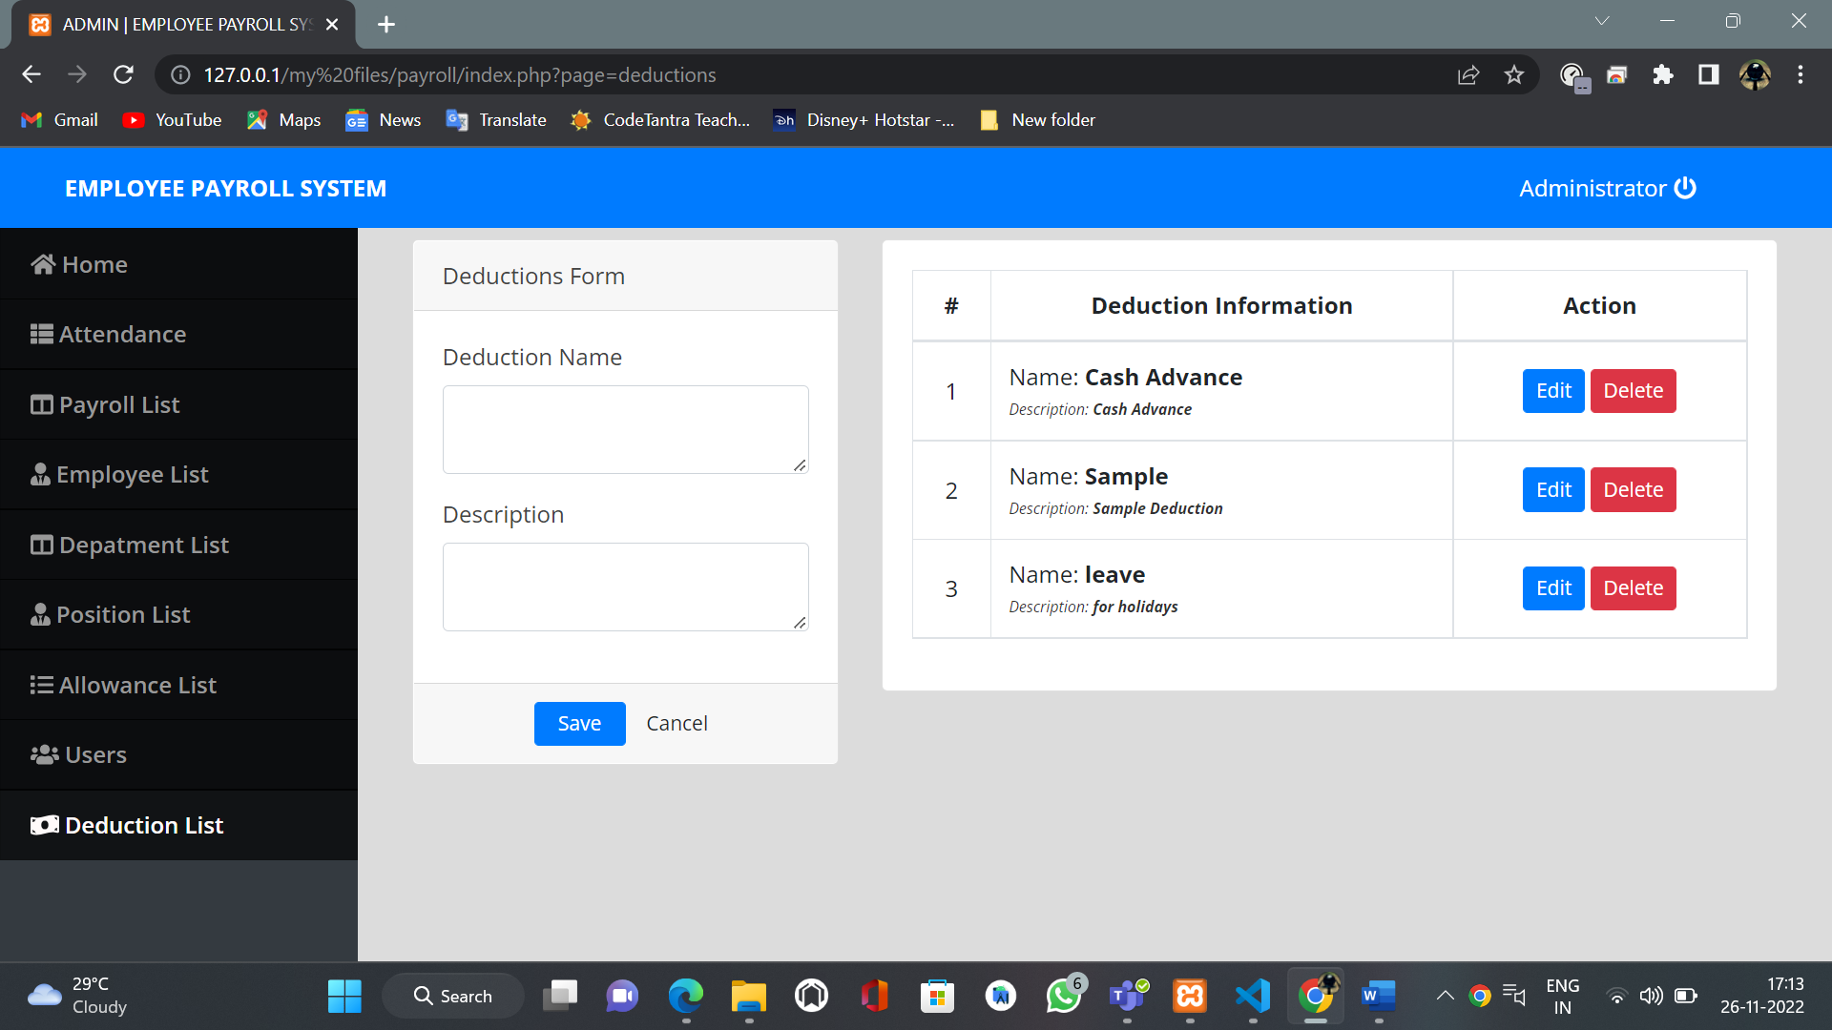

Users list :

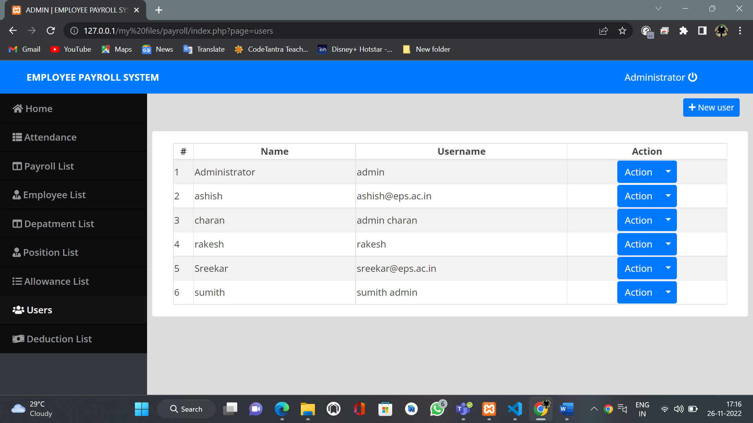

Edit users / new users list :

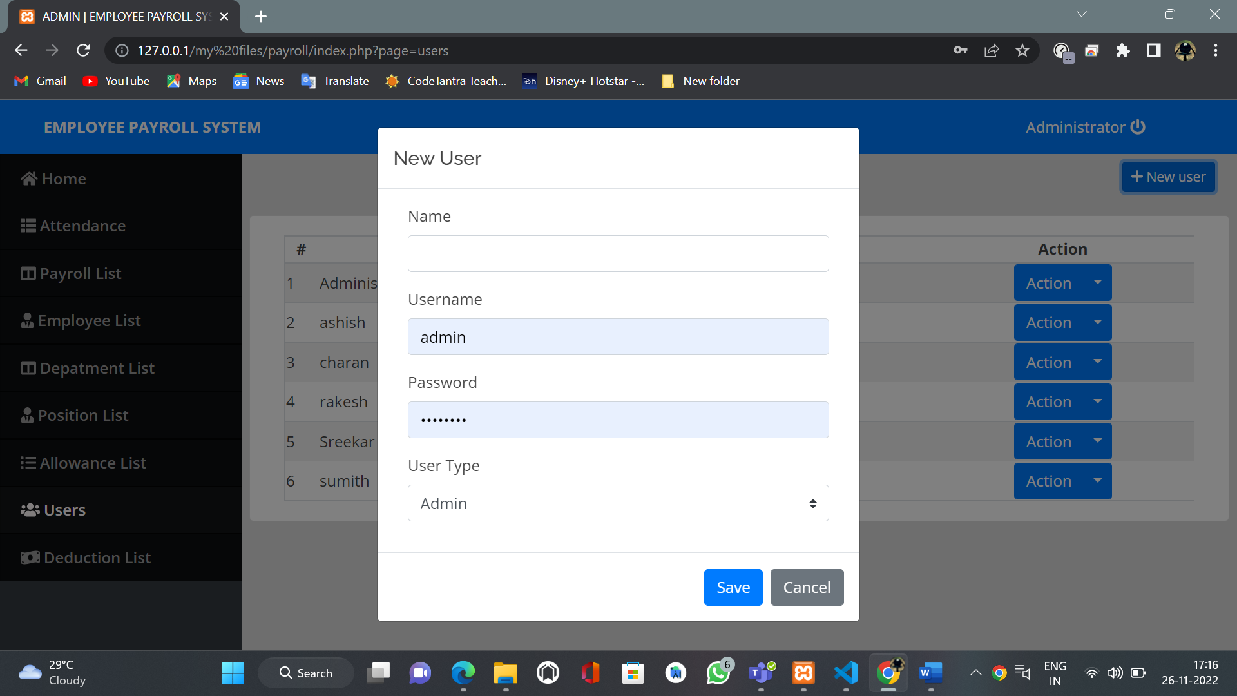

Database:

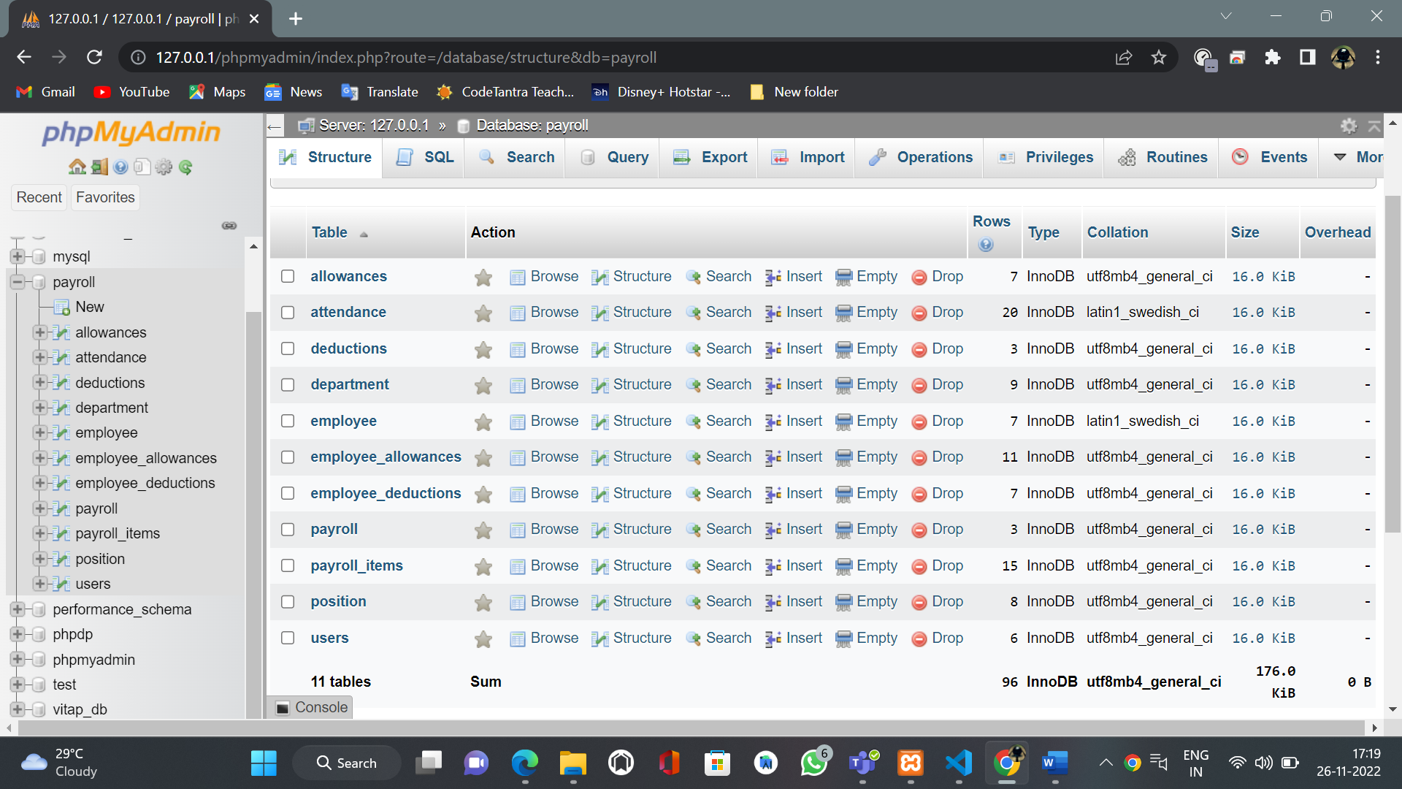

TESTING:

Admin and User Testcases:

|  |  |  |  |
| --- | --- | --- | --- |
| Test cases | Expected | actual | Pass/fail |
| Employees/admin login with mail | Employee/admin id mail @eps.ac.in | Employee/admin id mail@gmail.com | Fail |
| Employee/admin id’s | Admin / sreekar | Admin | pass |
| Phone numbers | Registered numbers | Not registered numbers | Fail |
| password | id@123 | Id/ own password | fail |

If user enters wrong email id or password while logging in the system will display this error.

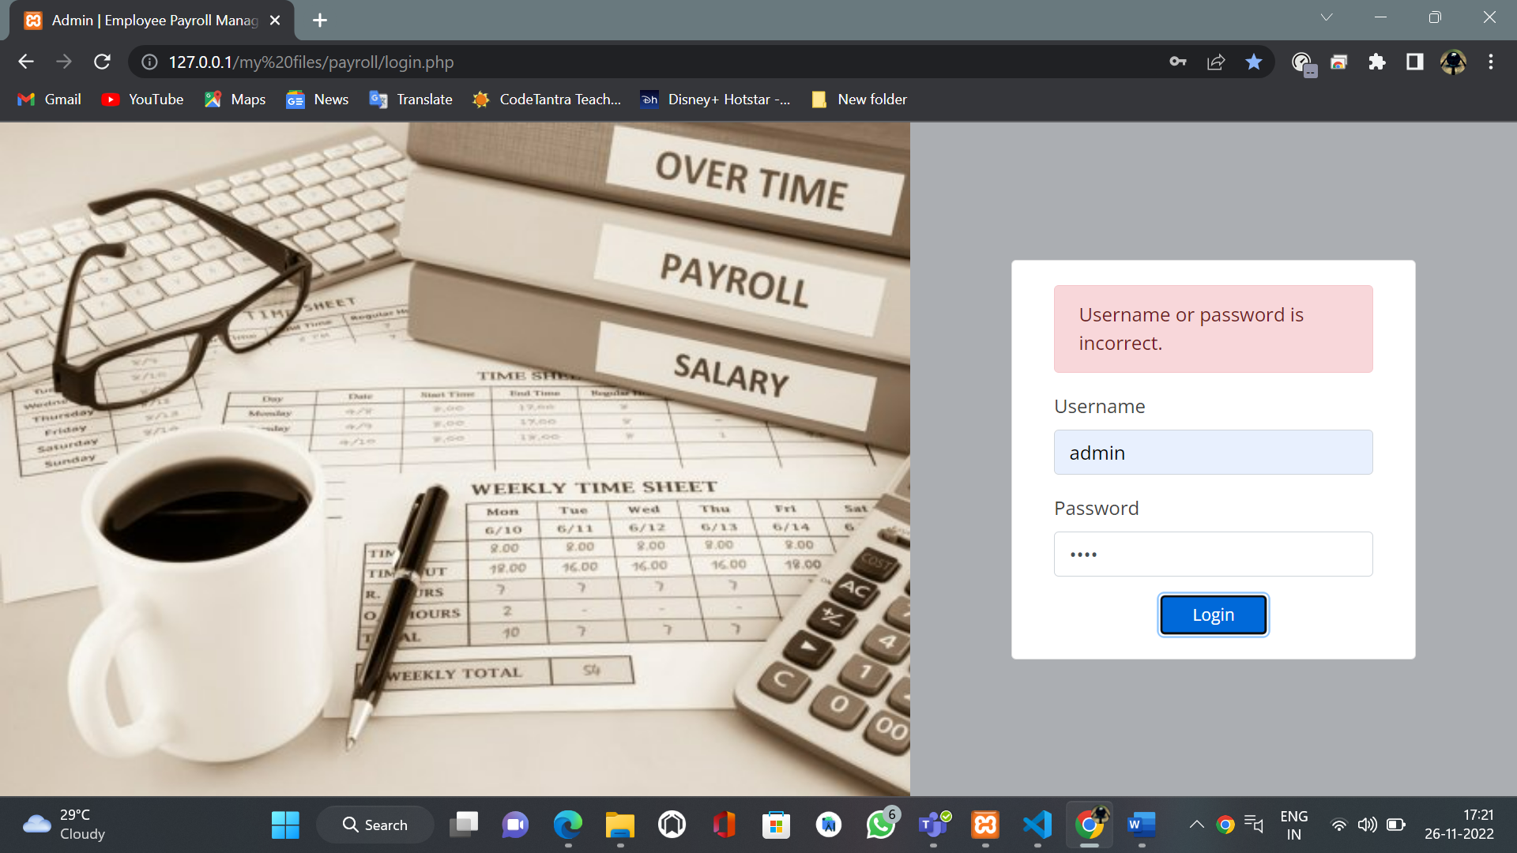

User/Admin interfaces testing:

Users

Admins

Users and admins : both

|  |  |  |  |
| --- | --- | --- | --- |
| Test cases | expected | actual | Pass/fail |
| Employee details display | Both | Both | Pass |
| Edit employee details admins | Admins | Admins | Pass |
| Edit employee details | Admins | Users | Fail |
| Leave apply | Both | Both | Pass |
| Payroll list display | Both | Both | Pass |
| Edit payroll for employee | Admin | Admin | Pass |
| Edit payroll for employee | Admin | Users | Fail |
| New project ideas | Users | Users | Pass |
| New user | Admin | Admin | Pass |
| New user | Admin | Users | Fail |
| Delete employee | Admin | Admin | Pass |
| Delete employee | Admin | Users | Fail |
| Change passsword | Admin | Admin | Pass |
| Reset password | Admin | Admin | Pass |
| Bonus in allowance list | Admin | Users | Fail |
| Payroll report update | Admin | Admin | Pass |
| Payroll report update | Admin | Users | Fail |
| Allowance list display | admin | admin | Fail |
| Allowance list edit/add | Admin | Admin | Pass |
| Department list display | admin | admin | Fail |
| Department list edit/add | Admin | Admin | Pass |
| position list display | admin | admin | Fail |
| Position list edit/add | Admin | Admin | Pass |

Security and network testing:

|  |  |
| --- | --- |
| Test cases | Pass/fail |
| 24/7 working system | pass |
|  |  |

**IMPLEMENTATIONS:**

**CODES:**

**ASSETS:**

**CSS:**

  

**DataTables:**



**font-awesome:**



**Js:**



**vendor:**

**BOOTSTRAP:**

**CSS:**



**JS:**



**VENOBOX:**



**DATABASE:**



**WEB PAGES:**

